## Min-Max notation continued…

* In an ER with (min, max) notation we don’t need double lines except for weak entities and their identifying relationships.
* Place of cardinality ratio numbers are opposite in (min, max) notation than in the previous notation.
* 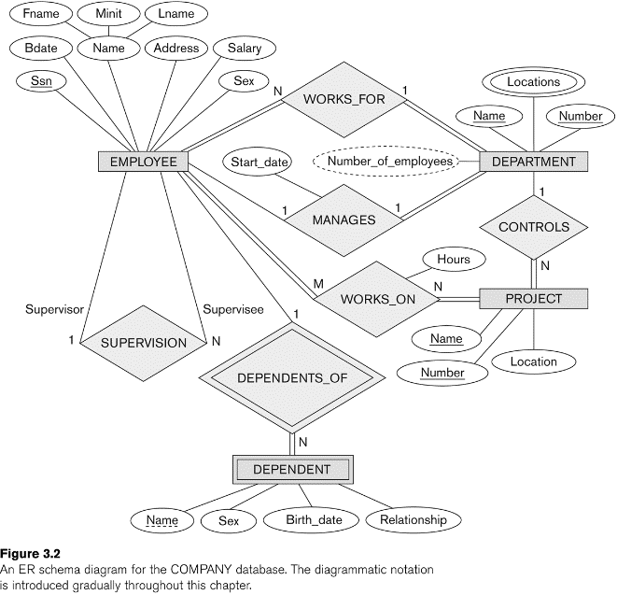Compare min-max notation vs. the previous one in the following ERs:

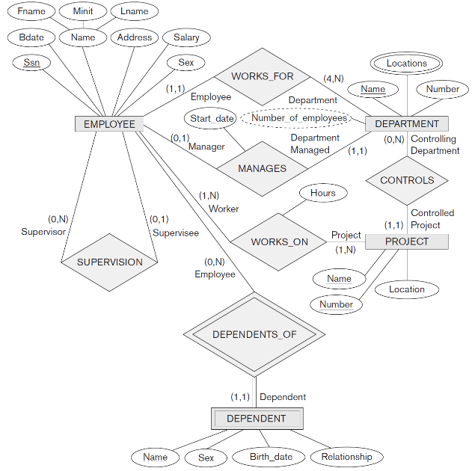

## Summary of ER diagrams

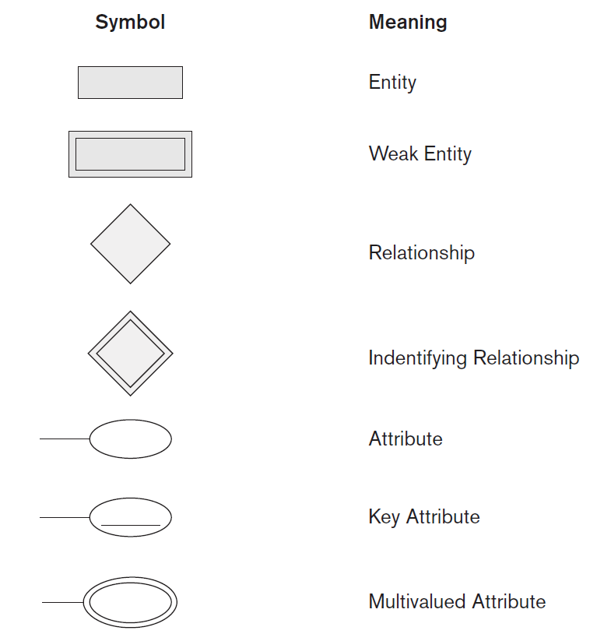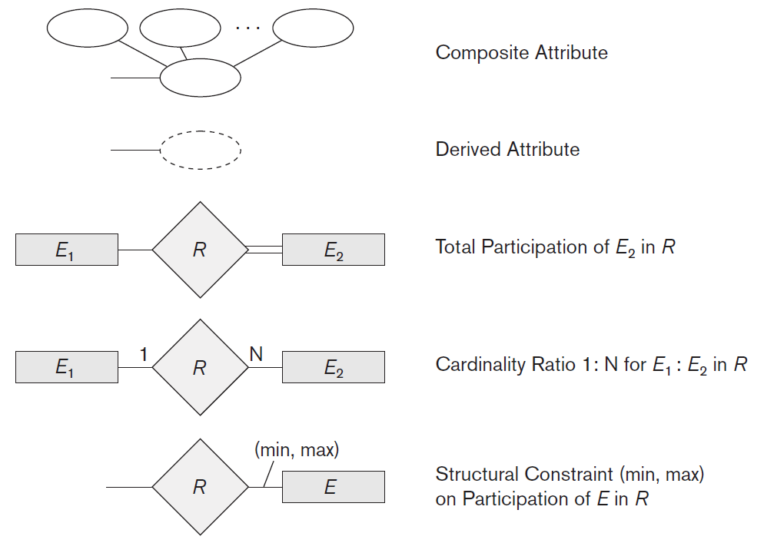

## N-ary Relationships

If a relationship connects N different entities, then its called n-ary relationship;

* Similarly relationships of degree 3 are called ternary.
* Relationships of degree 2 are called bi-nary.

## Another ER Example, University Database

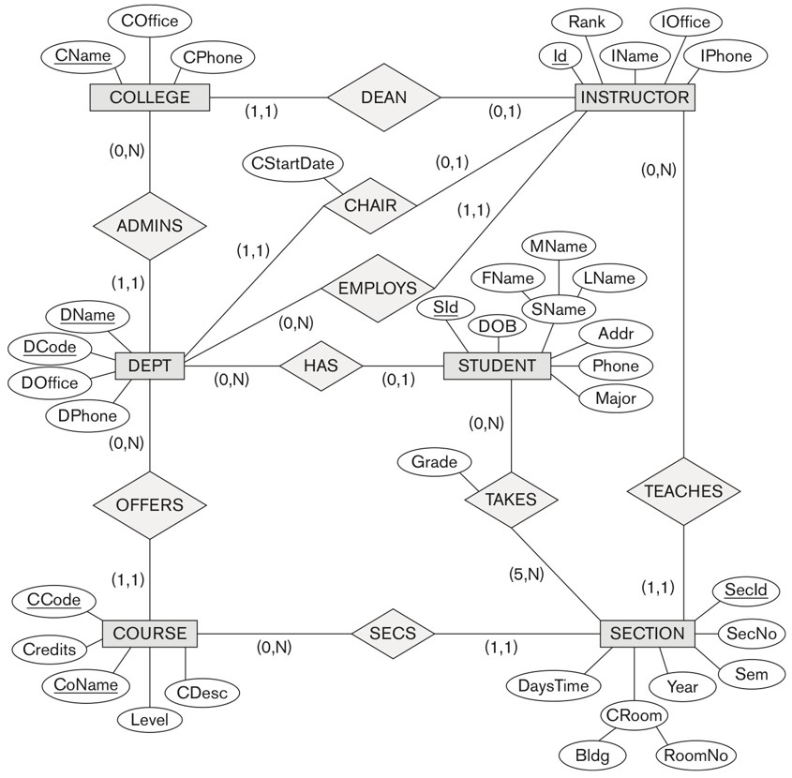

Based on this ER, answer the following questions:

* What is the minimum size of a course section?
* Every instructor must teach at least one course section, True or False?
* A course should have at least one section, True or False?
* Some department does not offer any courses, True or False?
* All students must be assigned to a department, True or False?
* Some department could have no instructor but must have a Chair, True or False?

**End of Chapter 3**